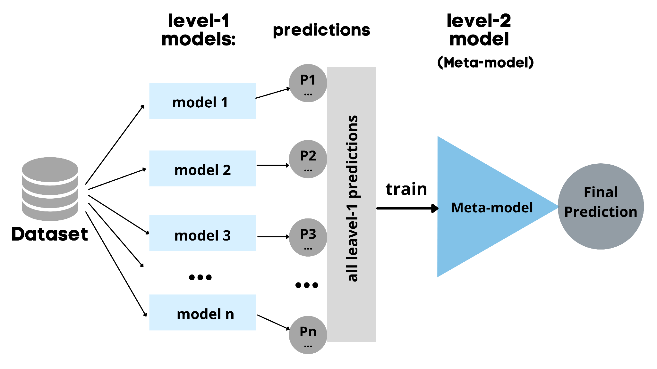

**Figure 3.**Stacking structure.